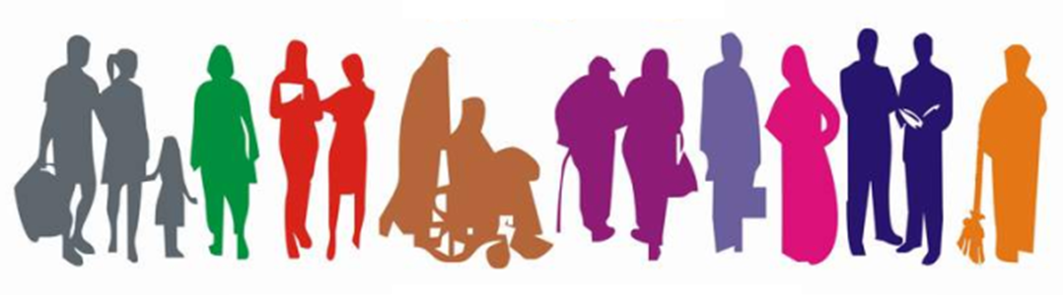

STUDENT Equality Information
2016/2017
Student Equality Data 2016-2017
Religious Belief
Description | Count | %
Roman Catholic | 8961 | 52.68%
None | 3254 | 19.13%
Not stated - MIS use only | 1986 | 11.68%
Presbyterian Church in Ireland | 1229 | 7.23%
Church of Ireland | 729 | 4.29%
Other Religion | 396 | 2.33%
Other Christian | 251 | 1.48%
Buddhist | 71 | 0.42%
Methodist | 71 | 0.42%
Muslim | 18 | 0.11%
Jewish | 14 | 0.08%
Hindu | 12 | 0.07%
Other | 11 | 0.06%
Sikh | 5 | 0.03%
Baptist | 1 | 0.01%
Grand Total | 17009 | 100.00%

Political Opinion
Description | Count | %
Not stated - MIS use only | 6367 | 37.43%
Prefer not to say | 4452 | 26.17%
Nationalist | 3819 | 22.45%
Other | 1285 | 7.56%
Unionist | 973 | 5.72%
None | 113 | 0.66%
Grand Total | 17009 | 100.00%

Racial Group
Description | Count | %
White | 15766 | 92.69% | -
Not Stated - MIS use only | 959 | 5.64% | 77.15%
Mixed Ethnic Other | 78 | 0.46% | 6.28%
Any Other Ethnic Group | 59 | 0.35% | 4.75%
Black African | 41 | 0.24% | 3.30%
Irish Traveller | 36 | 0.21% | 2.90%
Chinese | 22 | 0.13% | 1.77%
Indian | 18 | 0.11% | 1.45%
Black Caribbean | 11 | 0.06% | 0.88%
Black Other | 8 | 0.05% | 0.64%
Bangladeshi | 6 | 0.04% | 0.48%
Pakistani | 5 | 0.03% | 0.40%
Grand Total | 17009 | 100.00% | 100.00%

Age
Description | Count | %
18 and under | 7243 | 42.58%
19 to 30 | 4082 | 24.00%
31 to 40 | 2225 | 13.08%
41 to 50 | 1599 | 9.40%
51 to 60 | 1009 | 5.93%
61 and over | 851 | 5.00%
Total | 17009 | 100.00%

Marital Status
Description | Count | %
Single | 11855 | 69.70%
Not stated - MIS Use only | 2216 | 13.03%
Married | 2046 | 12.03%
Separated | 287 | 1.69%
Divorced/Dissolved | 278 | 1.63%
In a civil partnership | 186 | 1.09%
Widowed/Surviving partner | 138 | 0.81%
Other | 3 | 0.02%
Grand Total | 17009 | 100.00%

Sexual Orientation
Description | Count | %
Heterosexual/Straight | 11601 | 68.21%
Not Stated - MIS use only | 3580 | 21.05%
Prefer not to say | 1435 | 8.44%
Bisexual | 182 | 1.07%
Gay | 130 | 0.76%
Lesbian | 73 | 0.43%
Other | 8 | 0.05%
Grand Total | 17009 | 100.00%

Gender
Description | Count | %
Female | 9207 | 54.13%
Male | 7802 | 45.87%
Grand Total | 17009 | 100.00%

Gender
Description | Count | %
None | 12721 | 74.79%
Specific learning disability (eg dyslexia, dysgraphia) | 1321 | 7.77%
Disability, Special Need or Medical Condition | 1212 | 7.13%
Unknown | 467 | 2.75%
Mental health difficulty | 228 | 1.34%
Not Stated | 187 | 1.10%
Autistic spectrum disorder/Asperger's syndrome | 186 | 1.09%
Two or More | 160 | 0.94%
Unseen Disability (eg diabetes, epilepsy) | 157 | 0.92%
Wheelchair or mobility difficulty | 145 | 0.85%
Blind or partially sighted | 97 | 0.57%
Other | 68 | 0.40%
Deaf or hard of hearing | 60 | 0.35%
Grand Total | 17009 | 100.00%

Dependant Child
Description | Count | %
No | 15336 | 90.16%
Yes | 1673 | 9.84%
Grand Total | 17009 | 100.00%

Dependant Adult
Description | Count | %
No | 16726 | 98.34%
Yes | 283 | 1.66%
Grand Total | 17009 | 100.00%

Community Background
Description | Count | %
Roman Catholic | 9968 | 58.60%
Protestant | 2854 | 16.78%
Not stated - MIS use only | 2685 | 15.79%
No Religion | 1191 | 7.00%
Other Christian | 247 | 1.45%
Non-Christian | 61 | 0.36%
Other | 3 | 0.02%
Grand Total | 17009 | 100.00%

